Telling Lives: The Lost Ones
Analyzing a Documentary Film and Primary Sources to Piece Together a Story (http://www.carlisleindian.dickinson.edu)
Overview: They came from all over the country, from almost every nation. The Carlisle Indian Industrial School in Pennsylvania was the first federally funded off-reservation Indian boarding school founded in 1879 by Captain Richard Henry Pratt. Until its closing in 1918, over 10,500 children were sent to the school to become “civilized” and learn the white man’s ways and language. Pratt believed that American Indians were the equals of European-Americans, and that Native American children immersed in mainstream Euro-American culture would become assimilated and loyal to the United States. While some communities and families were persuaded to send their children, other children were captured and sent to Carlisle as prisoners of war. Controversies over this “experiment” are still debated: Was this a reasonable progressive experiment in assimilationist education or a form of cultural genocide? Why are there multiple perspectives?
Plan:
One class period:
See the Trailer for The Lost Ones: Long Journey Home (bi-lingual: English and Spanish – 18 minutes): https://www.youtube.com/watch?v=_I4jF22bXeA
Why are these two people referred to as The Lost Ones?

In what ways were they lost?

Who lost what?

How were they found?

Summarize the story of these two children in 4-5 sentences.
You may want to consider the following questions:
Where did they come from and why/how did they leave home?
How did they end up at the Carlisle Indian School?
What were they taught there?
What were the expectations for Kasetta as a girl and Jack as a boy?
What happened to Kasetta? And to Jack?
Who is Dick (Richard) Kaseeta?
How do we know at least this part of their story?
______________________________________________________________________________________________________________________________________________________________________________________________________________________________________________________________________________________________________________________________________________________________________________________________________________________________________________________________________________________________________________________________
2nd Class period
Analyzing Photographs: In establishing the Carlisle Indian School, Captain Henry Richard Pratt’s goal was to assimilate American Indians into mainstream European-American culture. In order to document his experiment in civilizing Indian children, he commissioned John N. Choate to take before and after “contrast” photos.
The most famous set of these before and after photographs is of Tom Torlino (Navajo) upon arrival at the Carlisle Indian School in 1882; the second photograph of him was taken in 1885.
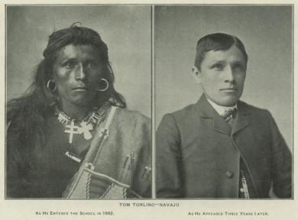

- Describe what you see in the first photo on the left.
______________________________________________________________________________________________________________________________________________________________________________________________________________________________________________________________
- Describe what you see in the 2nd photograph on the right.
_______________________________________________________________________________________________________________________________________________________________________________________________________________________________________________________________
Here is a group picture of Navajo Students upon arrival in 1882, including Tom Torlino, sitting in the front row, bottom left. Richard Henry H Pratt looks on from the bandstand. | This is a photograph of the same group Navajo students who entered Carlisle October 21, 1882 after some time at the school.

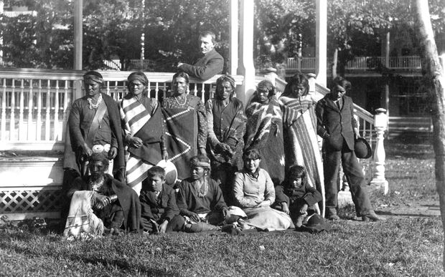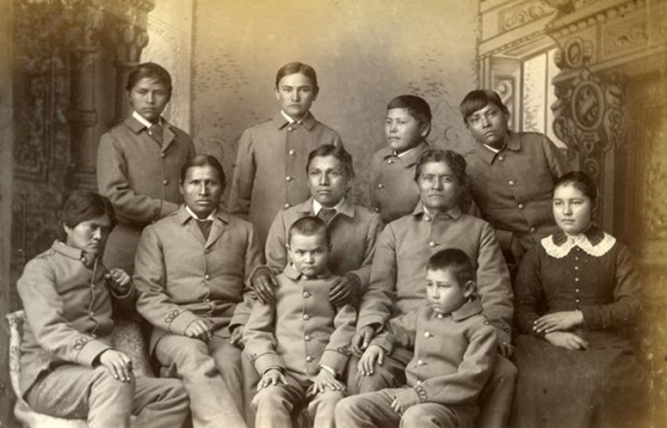
- Describe what you see in each photograph. What impression do the two photographs give?

- What purpose might the before and after photos have served for Pratt and the Carlisle Indian School?

Below are two photographs of Jack and Kasetta, referred to as The Lost Ones. The 1st was taken in Kansas and the 2nd at Carlisle within a couple of months of one another, both in 1880.
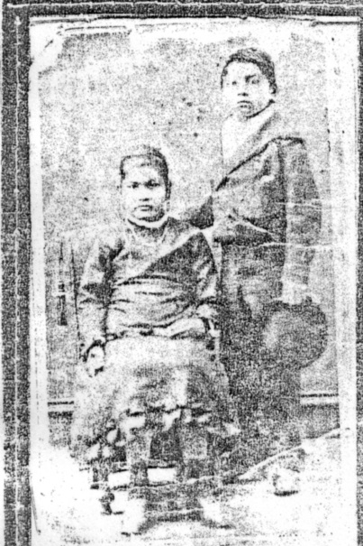
- What do you see when you look at these images of Jack and Kasetta?

- Consider the irony here. How may these photographs be used to both erase and reclaim one’s identity? (refer back also to the documentary)

3rd class/option Analyzing Primary Documents - The Lost Ones
Go to carlisleindian.dickinson.edu and search the student file for Richard Keseeta (in it you will also find information about Jack and Kesetta - also spelled Kasetta, Krisetta…).
Two narratives have been maintained throughout the decades – from the 1870s into to the 21st century. One has been expressed primarily by government and school officials through written documents, publications, student files, and images; the other has been told primarily through intergenerational and family oral histories. How would you describe the two narratives you heard in the documentary? How do they overlap or conflict with one another?
Kasetta was the longest enrolled student at the Carlisle Indian Student. On her death certificate, she is still listed as a prisoner of war. What do you think descendants think of this?
Some consider Carlisle to have been a progressive experiment in Indian education and racial assimilation; others consider it to have been a form of cultural genocide. What do you think?
Additional Questions Students may want to Explore:
Names: Throughout their lives, both Jack and Kasetta were given various names (and the archives and tombstones reveal various spellings of their names). What does such variation suggest about the change and continuity in their lives?
Reflect on what names are important to you? What’s in a name? Why might one’s name be changed or kept? What difference does it make? Are there parallels here to the naming of immigrants as they enter a new culture?
Gender: Kasetta was a young girl when she was captured and therefore did not have the opportunity to participate in a puberty ceremony “to become a woman” in her native tradition. Instead what was she taught as a girl at the Carlisle Indian School?
You may want to search on-line for what a puberty ceremony is like among the Apache (Lipan Apache) or other Native Groups?
What expectations did the Apache (other Nations) have for women and for men? How were men and women valued? How was masculinity and femininity defined?
What are your impressions of this story?

4th option/class Analyze (compare and contrast) the following quotations.
Speaking to a convention of Baptist ministers in 1883, Captain Henry Richard Pratt, the founder of the Carlisle Indian School, used the image of baptism to explain his philosophy for transforming Native children so they could be made to emulate white men and women:

In Indian civilization I am a Baptist, because I believe in immersing the Indians in our civilization and when we get them under holding them there until they are thoroughly soaked.
Pratt requested permission from the Secretary of the Interior, Carl Schurz, to found a school exclusively for Indians:

…give me 300 young Indians and a place in one of our best communities and let me prove it is easy to give Indian youth the English language, education, and industries that it is imperative they have in preparation for citizenship. Carlisle Barracks in Pennsylvania has been abandoned for a number of years. It is in a fine agricultural country and the inhabitants are kindly disposed and long free from the universal border prejudice against Indians.

Now read and analyze the following two quotes:

"The common schools
are the stomachs of the country
in which all people that come to us
are assimilated within a generation.
When a lion eats an ox,
the lion does not become an ox
but the ox becomes a lion."
...Henry Ward Beecher

"If the Great Spirit had desired me
to be a white man
he would have made me so
in the first place.
He put in your heart
certain wishes and plans;
in my heart he put
other and different desires.
Each man is good
in the sight of the Great Spirit.
It is not necessary,
that eagles should be crows."
..Sitting Bull (Teton Sioux)

What is Henry Ward Beecher’s major argument?

What is Sitting Bull’s counter argument? What would he say to Henry Ward Beecher?

Which of the above arguments would Pratt agree with?

Which do you think is the stronger argument? Explain your rationale.

Resources:
Bibliography
For more context screen the full documentary The Lost Ones: Long Journey Home is available at csc@dickinson.edu. The Lost Ones: Long Journey Home documents the story of two Lipan Apache children captured along the Texas-Mexican border in 1877 by the 4th U.S. Cavalry. After the massacre of their village known as the "Day of Screams," the children rode from fort to fort with the Calvary for three years before being taken to the Carlisle Industrial Indian School (CIIS) in Pennsylvania. Ties with their family were completely severed. The only legacy the children left was Kasetta's three year-old son who became the youngest child ever to be enrolled at CIS. While the family remembered the Lost Ones every year, they never knew what had happened to the children or where they were buried until two centuries later. This documentary reveals the mystery of how in 2009 on the anniversary of Remolino, Lipan Apache descendants from California, Texas, and New Mexico came to Carlisle to offer blessings so the children could be sent home. This trailer for YouTube has been approved by the Lipan Apache Band of Texas Elders Committee. Many thanks to Daniel Castro Romero, Jr., Jackie Fear-Segal, Barbara Landis, Richard Gonzalez, Anita Anaya, and Manuel Saralegui. For more information about the 42 minute film and the 20 minute "Piecing Together the Story: Methodological Reflections," contact Susan Rose at the Community Studies Center at Dickinson College (csc@dickinson.edu). Available with Spanish subtitles or with a 23 minute historical video essay: “Piecing Together the Story: Methodological Reflections.”

Robert M Utley, ed., Battlefield and Classroom: Four Decades with the American Indian, 1867-1904, by Richard Henry Pratt (Lincoln: University of Nebraska Press, 1964), xxiii.
Utley, ed., Battle field and Classroom, 215-216.

