Locations of Off-Reservation Indian Boarding Schools in the U.S.

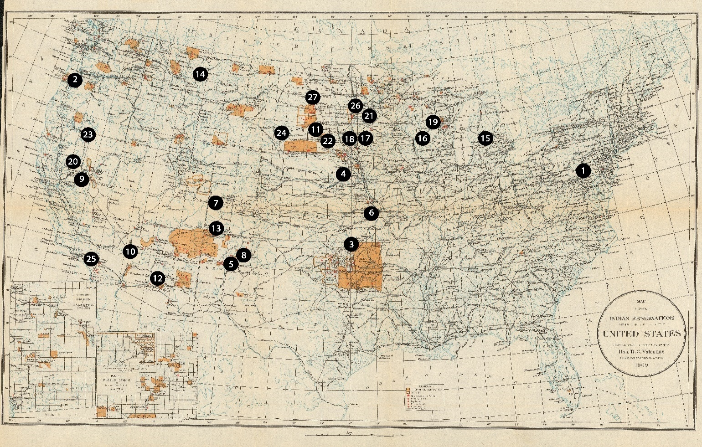

- Carlisle Indian Industrial School (Carlisle, Pennsylvania) – opened October 1879
- Chemawa Indian School (Salem, Oregon) – opened February 1880
- Chilocco Indian School (Chilocco, Oklahoma) – opened January 1884
- Genoa Indian Industrial School (Genoa, Nebraska) – opened February 1884
- Albuquerque Indian School (Albuquerque, New Mexico) – opened August 1884
- Haskell Industrial Training School (Lawrence, Kansas) – opened September 1884
- Grand Junction Indian School (Grand Junction, Colorado) – opened 1886
- Santa Fe Indian School (Santa Fe, New Mexico) – opened October 1890
- Stewart Indian School (Carson City, Nevada) – opened December 1890
- Fort Mojave Industrial School (Fort Mojave, Arizona) – opened December 1890
- Pierre Indian School (Pierre, South Dakota) – opened February 1891
- Phoenix Indian School (Phoenix, Arizona) – opened September 1891
- Fort Lewis Indian School (Fort Lewis, Colorado) – opened March 1892
- Fort Shaw Indian Boarding School (Fort Shaw, Montana) – opened December 1892
- Mount Pleasant Indian Industrial School (Mount Pleasant, Michigan) – opened January 1893
- Tomah Indian Industrial School (Tomah, Wisconsin) – opened January 1893
- Pipestone Indian School (Pipestone, Minnesota) – opened February 1893
- Flandreau Indian School (Flandreau, South Dakota) – opened March 1893
- Wittenberg Indian School (Wittenberg, Wisconsin) – opened August 1895
- Greenville Indian Industrial School (Greenville, California) – opened September 1895
- Morris Industrial School for Indians (Morris, Minnesota) – opened April 1897
- Chamberlain Indian School (Chamberlain, South Dakota) – opened March 1898
- Fort Bidwell Indian School (Fort Bidwell, California) – opened April 1898
- Rapid City Indian School (Rapid City, South Dakota) – opened September 1898
- Sherman Institute (Riverside, California) – opened July 1902
- Wahpeton Indian School (Wahpeton, North Dakota) – opened February 1908
- Bismarck Indian School (Bismarck, North Dakota) – opened December 1908

