Overview
Teaching Modules for the Carlisle Indian School Digital Resource Center
(www.carlisleindian.dickinson.edu)
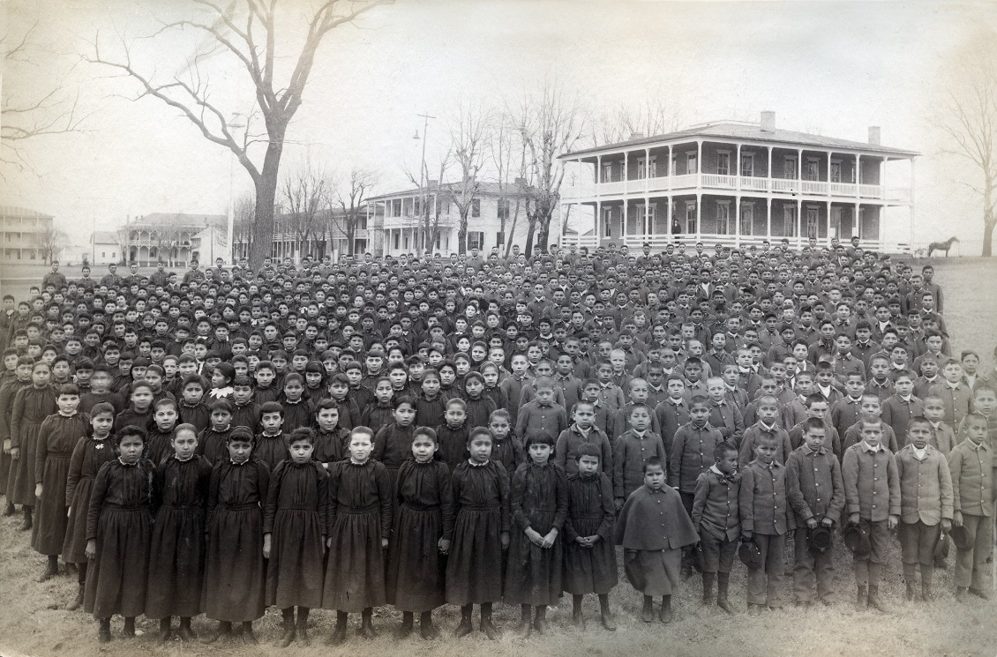
Group photo of the Entire Student Body at the Carlisle Indian School, 1892

Tens of thousands of young people from Indian communities all across America were sent to the Carlisle Indian School in Pennsylvania between 1879-1918. What was the purpose, the strategy, the outcome? What can we learn from interrogating this historical, educational experiment about the goals of its founders, the students who were sent there, the impact on their families and communities, U.S. military and domestic policy related to Indian tribes, the history of American education, about race and ethnic relations?
Because of the significant role it played in American and Native American history the Carlisle Indian Industrial School (CIS) continues to be a major site of memory for many Native peoples across the U.S. and Canada, as well as a source of research and study for descendants, students and scholars around the globe. Lesson Plans have been designed around various themes and skills for both secondary (8-12) and college and university classes. The aim is to guide teachers, students, and researchers as they begin to explore and use this digital resource center. Teacher guides, followed by student worksheets, are posted in WORD so that people can easily and freely access and adapt them.
Background Description
The Carlisle Indian Industrial School (CIS) served as the model for off-reservation boarding schools across the U.S. and Canada. Operating from 1879-1918, CIS enrolled over 10,000 students from across the United States. Rather than continue the costly “Indian wars,” the founder of Carlisle, Capt. Henry Richard Pratt convinced Congress that schools such as Carlisle should be established to assimilate and “civilize” Indian children. Who were these students? Where did they come from? How did they come to be enrolled at CIIS? What was the mission of the school and how successful was this “experiment in educating and assimilating Native American young people?” What were students taught? What methods were used? How was life at the school structured? What kinds of medical facilities did the school have? What forms of discipline were used? How did it affect students’ lives after they left the school? What legacies remain?
The site provides over 300,000 pages of documents, from individual student files (arrival information, outing, medical, and financial records, and correspondence) to ledgers, rosters, images, and publications, all related to the Carlisle Indian School.
Materials
Primary Documents
Carlisle Indian School student files, images, school publications – Carlisle Indian School Digital Resource Center
Capt. Henry Richard Pratt, Speech *Read: “Kill the Indian, and Save the Man”: Capt. Richard H. Pratt on the Education of Native Americans. Source: Official Report of the Nineteenth Annual Conference of Charities and Correction (1892), 46–59. Reprinted in Richard H. Pratt, “The Advantages of Mingling Indians with Whites,” Americanizing the American Indians: Writings by the “Friends of the Indian” 1880–1900 (Cambridge, Mass.: Harvard University Press, 1973), 260–271.
Excerpt from Pratt’s Speech
Shorter version for 8th-9th grades

Secondary Documents:
Introductory Essay to the Carlisle Indian School by Jacqueline Fear-Sega and Susan D. Rose (Background for teachers)
The Lost Ones: Long Journey Home documentary film trailer (bi-lingual: English and Spanish – 18 minutes): https://youtu.be/_I4jF22bXeA
Bibliography of major sources focusing on the Carlisle Indian School

Maps:

Locations of Off-Reservation Indian Boarding Schools in the U.S.
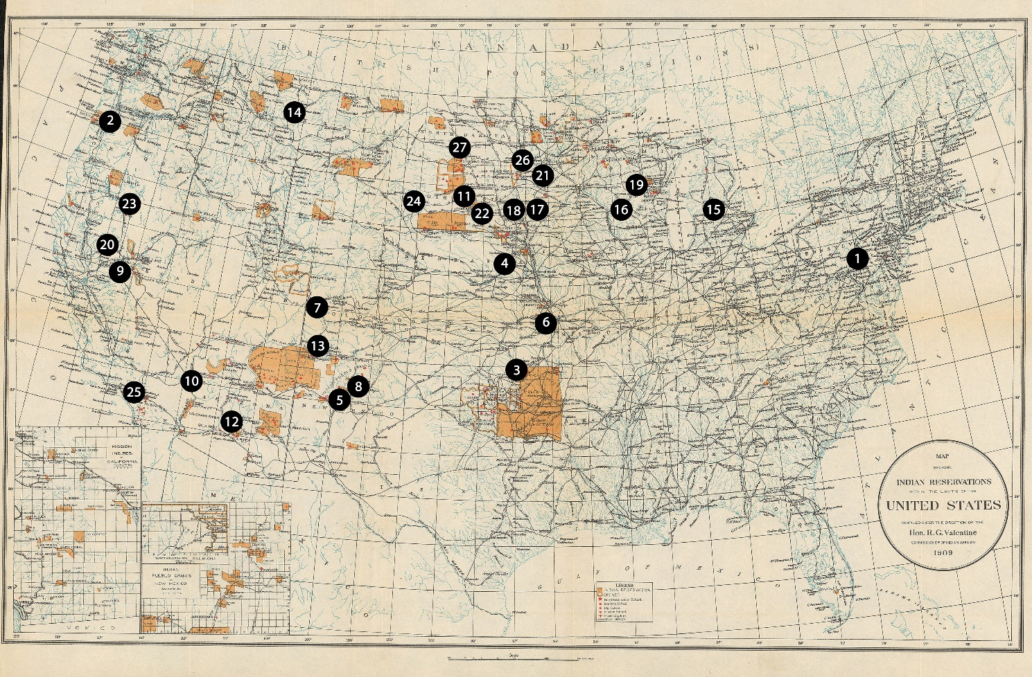

Carlisle Boarding School Maps of Buildings and Site – 1879 and 1918
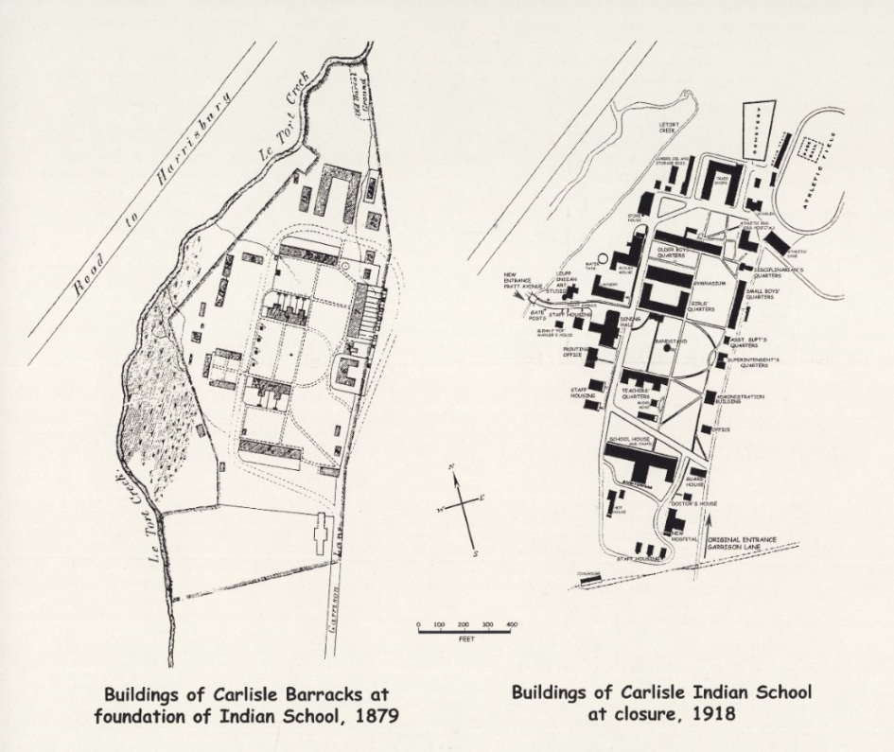

Curricular Contexts
The goal of the lesson plans is to guide people in their exploration of the Carlisle Indian School Digital Resource Center and what it has to offer. Much can be learned by searching through the primary documents, including student files and school publications – and also consulting secondary sources. These lesson plans can be adapted for college or high school classes or community workshops.
Some of the lesson plans have been designed for use in college and university classes, and others for middle and high school units (including AP classes) relating to American Indian and Native American history, 18th century frontier history, American Indian culture, the history of education in the U.S., Pennsylvania state history, military history, race and ethnic relations, scientific racism, enlightenment, contemporary social issues. Data-Based Questions (DBQs) are at the foreground as students are asked to analyze photographs, compare and contrast images and documents, do close-readings of primary and secondary sources, imagine themselves and others’ perspectives as they explore the site and create their own research projects, be they essays, creative writing assignments, research papers, timelines, posters, power points, or websites.
- Time Period: Late 19th century, Early 20th century,
- Rise of Industrial America, 1876-1900
- Progressive Era to New Era, 1900-1929
List of Interactive Lesson Plans
Analyzing Before and After Photographs and Primary Documents
Exploring and Investigating the Carlisle Indian School files by Name, Nation, Time, and Place
Comparing and Contrasting Arguments: Henry Ward Beecher, Sitting Bull, and Capt. Richard Henry Pratt
Telling Lives: The Lost Ones Analyzing a Documentary Trailer, Photographs, and Primary Documents
Close-Reading Teaching Modules
Teaching Module: Focus on Close Reading and Gender: College Level
Teaching Module: Focus on Indian Allotment and Land Tenure
Teaching Standards
More Resources Online for Content and Analysis
National Indian Law Library
Native American Peoples: General Information http://www.narf.org/nill/resources/general.html
US Army Heritage & Education Center
The US Army Heritage & Education Center features multiple photograph collections of the school grounds, buildings, students, teachers, and visitors at Carlisle Indian School from 1879 to 1918.
Library of Congress
The Library of Congress features a collection of photographs and prints from the Carlisle Indian School. It also offers a primary source set and teacher's guide entitled "Assimilation through Education". It features photographs, illustrations, newspapers, reports from the Commissioner of Indian Affairs about off-reservation boarding schools in the late 18th and early 19th centuries.
Radio Lab
Radio Lab features a podcast episode on the important role that Carlisle Indian School students played in the development of the modern sport of football in the United States. The host interviews local historians from the Cumberland County Historical Society, U.S. Army Heritage and Education Center, and Haskell Indian Nations University.
National Park Service
The National Register of Historic Places lists Carlisle Indian Industrial School. These records describe the physical site of the former school and its surroundings as well as their historical significance.
TNT: Into the West
TNT produced a mini-series called "Into the West" about assimilation at off-reservation boarding schools, using Carlisle Indian School as the setting. A brief clip is available on YouTube.
PBS
PBS offers an educational website and interactive map about the chronology of forced relocations, boarding schools, urban and reservation lives of American Indians today. The online resource is a supplement to the "Indian Country Diaries" documentary series.
Libraries and Archives of the Autry
The Libraries and Archives of the Autry and the Cante Sica Foundation of Boarding School Stories shares oral histories of former boarding school students. The collection features audiovisual recordings and time index of each person's memories of boarding school experiences.
New Mexico State Library
http://native-docs.org/

