Exploring the Carlisle Indian School Digital Resource Center – Student Files
An introductory lesson into the Carlisle Indian School website at http://carlisleindian.dickinson.edu/
Grade Level: Upper Elementary/Middle School
Time Frame: 2-3 class periods, depending on the length of your classes
Objective: To familiarize students how to find people from the Nez Perce (or their own) tribe and find out what information they can obtain from the records available.
Utilizing a database is an important life skill, especially in regards to historical records. Many students in our area also have connections to families that went to Carlisle Indian School, so there might also be a personal connection.
Common Core Standards:
6-8.RH.7 Integrate visual information (e.g., in charts, graphs, photographs, videos, or maps) with other information in print and digital texts.
6.RI.7 Integrate information presented in different media or formats (e.g., visually, quantitatively) as well as in words to develop a coherent understanding of a topic or issue.
CCRA.R.7 Integrate and evaluate content presented in diverse media and formats, including visually and quantitatively, as well as in words.
Resources/Materials needed:
The Lost Ones: Long Journey Home documentary film trailer (bi-lingual: English and Spanish – 18 minutes): https://youtu.be/_I4jF22bXeA
Computers – 1 for every 2 students, or 1 per student. (Depending on if you want them to work individually or in pairs.)
Carlisle Indian School student files, images, school publications – Carlisle Indian School Digital Resource Center
Directions:
First, play the video The Lost Ones: Long Journey Home documentary film trailer. Allow for 5-10 minutes of whole group discussion about impressions about the movie.
Here are possible leading questions:
- Were Nez Perce (or your tribe’s name here) people taken away to boarding schools?
- Do you know of anyone who has a relative that was taken away to a boarding school?
- Would people be able to do this to Natives (or any other group) in this day and age?
- Were all students forced to go to boarding schools?
- What would be the positive/negatives of going to a boarding school?
Next, direct students to go to the computers (decide beforehand if you prefer students to work individually or in pairs). If your tribe has very few Carlisle students, you may prefer pairs, or if you have students from another tribe, you may want to pair them together specifically so they can collaborate over their tribe’s information.

After students have logged on, direct them to: Carlisle Indian School Digital Resource Center
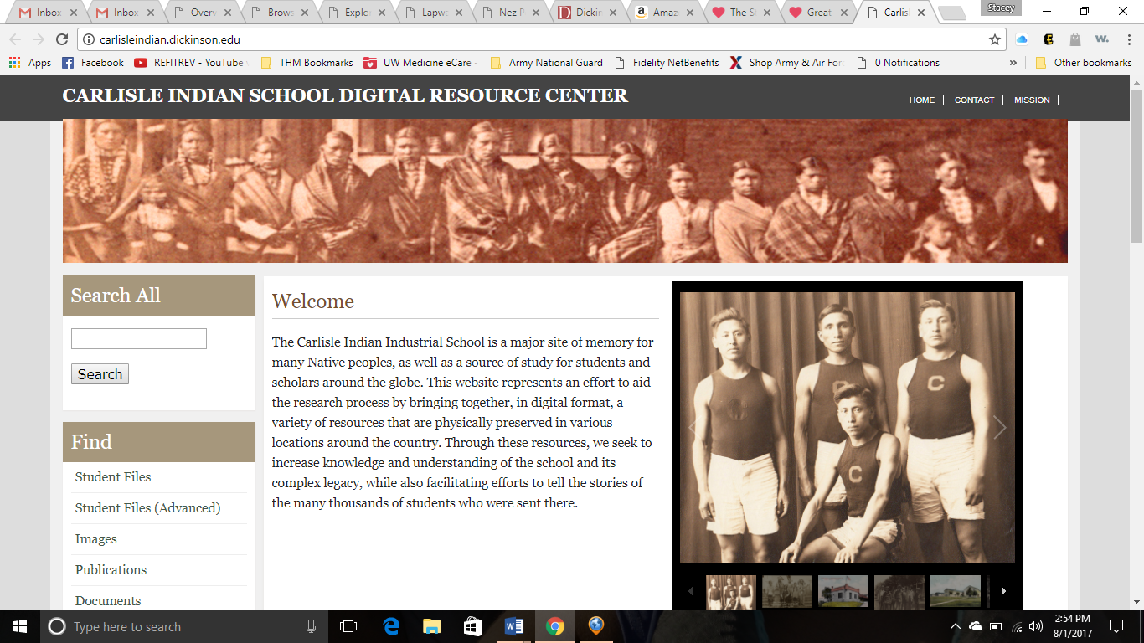
From here, direct them to the left hand side under “Find” and select Student Files (Advanced).
The page should look something like this:
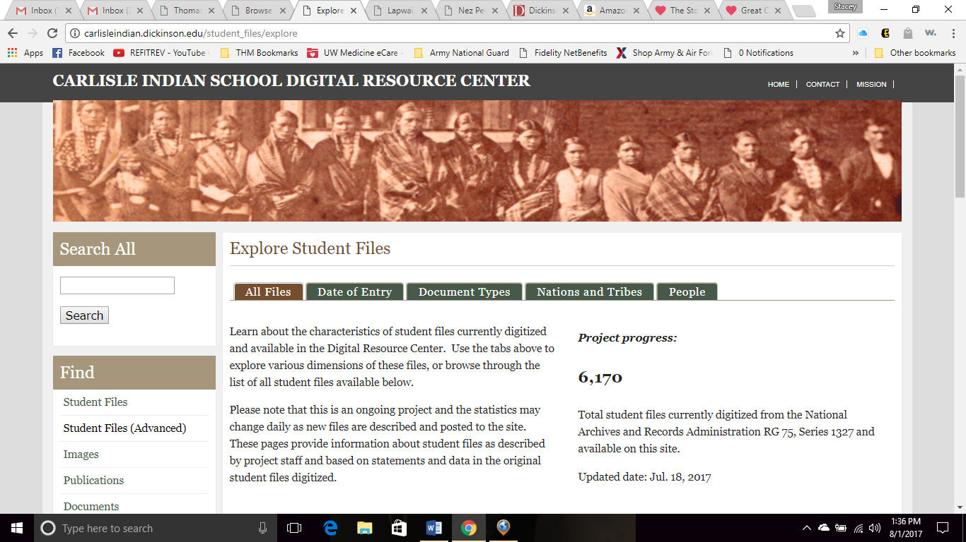

Next, scroll down. Under Nations and Tribes put NEZ PERCE (or the find the name of your tribe) and change the Items per page to 100 and hit “APPLY.”
** At this time, even if a student knew that they had a family member go to CIIS, I would still have them do this general search. Their family member should show up on the list anyway. **
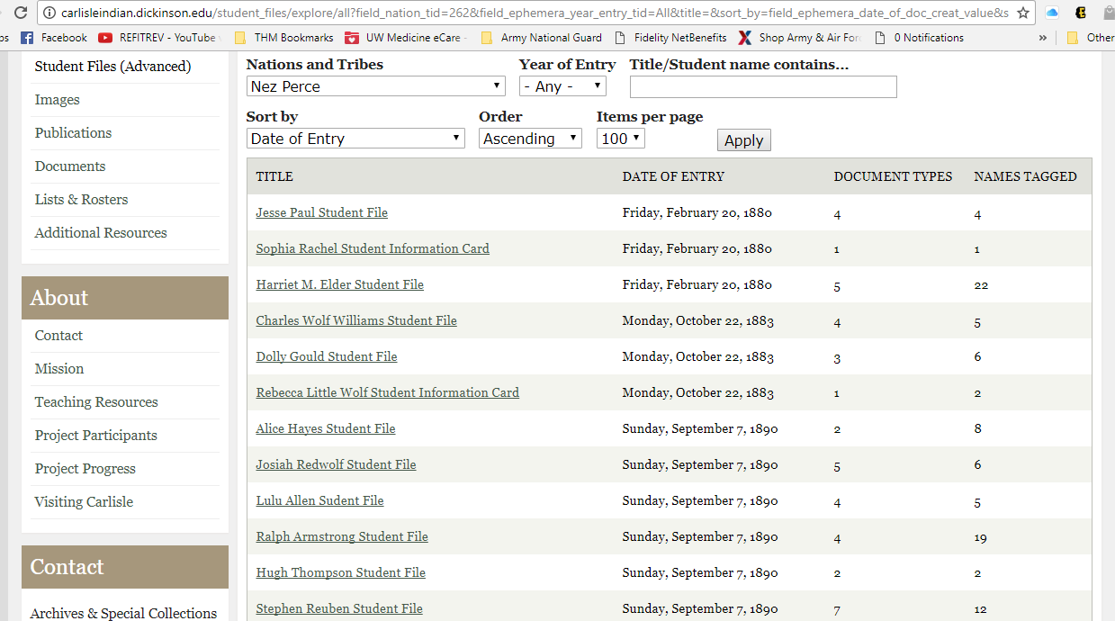
Scroll through the list, and here are some following things to possibly note/question:
- What does “Date of Entry” mean?
- What does it mean by “Document Types?”
- What does it mean by “Names Tagged?”
- Why do some students have multiple documents/tags, and some have very few?
Instead of giving these answers right away, open up a student’s file that has few vs. one that has many.
Go through one Carlisle student’s file (that has many documents) and show them the type of files that might be under each student.
Next, have each student (or pair) choose a name that is of interest to them. They can go through more than one just to compare and contrast files.
As individuals or partners, students will fill out the Carlisle Student Questionnaire (attached).
Give students time to finish their questionnaire and as time permits, have them compare with another pair/individual and what they have found.
Presenting materials – Have students (either volunteers or each student, depending on what you prefer) present their findings to the class, and allow them to show 1-2 items of interest they found in their student’s file.

My name:_______________________________ Class:__________________________
Carlisle Student Questionnaire
The name of the Carlisle Student:
Native name (if listed):
Tribe: Birthdate:
Date enrolled: Date left:
Does your student file have information about their life after they left Carlisle?
If so, what did you find out?

Other information you found interesting:

What information do you wish you had found in the file?

List 2 questions that you would have for this student.
1.)

2.)

