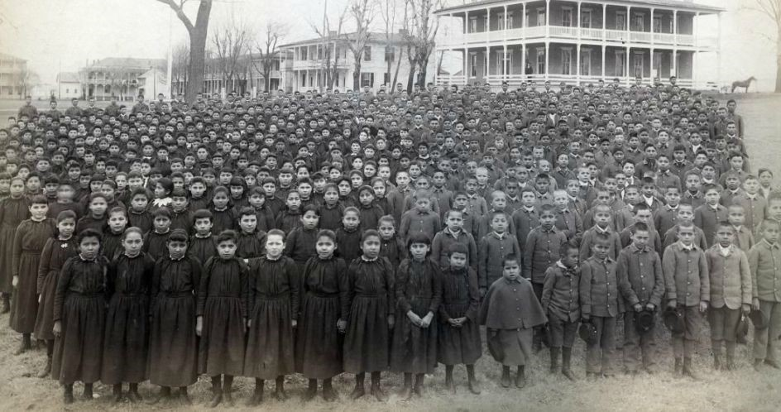
The student body of Carlisle Indian School, 1892.
Source: Carlisle Indian School Digital Resource Center, Dickinson College

Comprehension Questions for Document 1 1) What do you see in this image?

- How is the group of students in the image divided, and what differences between them can you perceive?

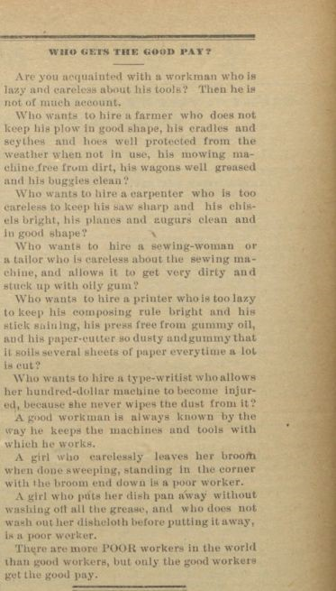
“Who gets the good pay?” ​The Indian Helper​, Carlisle Indian School, Oct. 24, 1890
Comprehension Questions for Document 2
- Analyze​ the use of pronouns in this article. How does it delineate between male economic roles and ​female​ economic roles being promoted at Carlisle?

- Does ​this​ differ from your knowledge of economic roles within a Native American society?

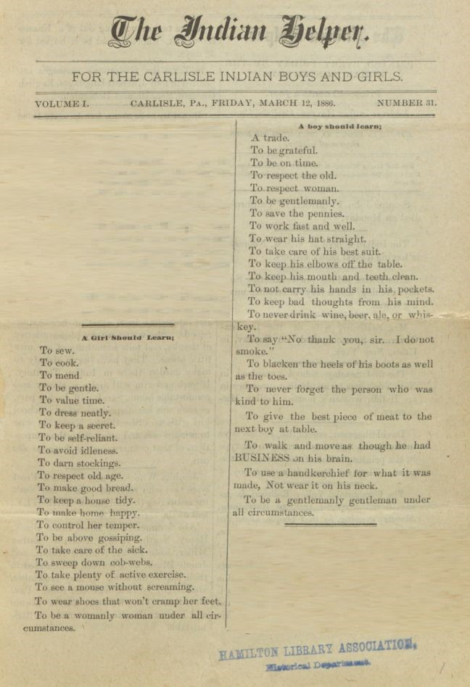
The Indian Helper​ (Newspaper published at Carlisle Indian School), March 12, 1886.

Comprehension Questions for Document 3
- Who​ do ​you​ think is the intended audience for Documents 2 and 3? How does the affect the content of the articles?

- Analyze​ ​the​ article above. How does it differentiate the social and cultural expectations between boys and girls at Carlisle?

- How ​could ​these​ roles be implemented at Indian boarding schools? Are these assigned roles reasonable?

- Describe ​any​ ​similarities or differences between these social roles and the roles within a Native
American tribe.

Document 4
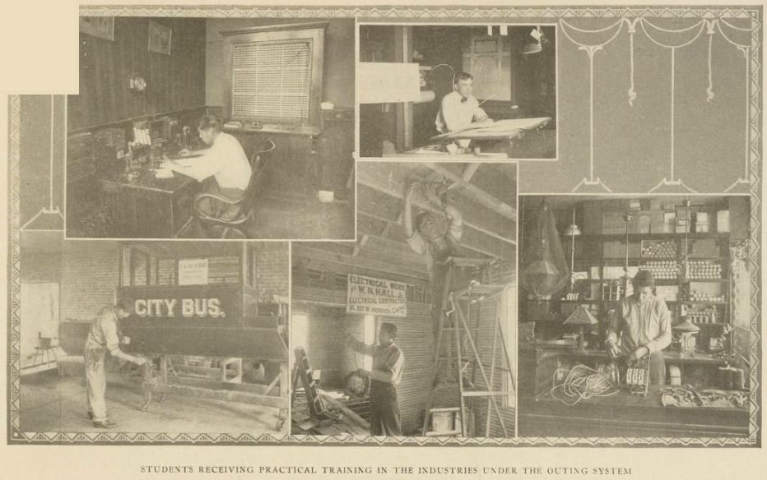
Caption: Students receiving practical training in the industries under the outing system
Red Man ​(a magazine published at Carlisle), vol. 4, no. 9 (May 1912): 382

Document 5
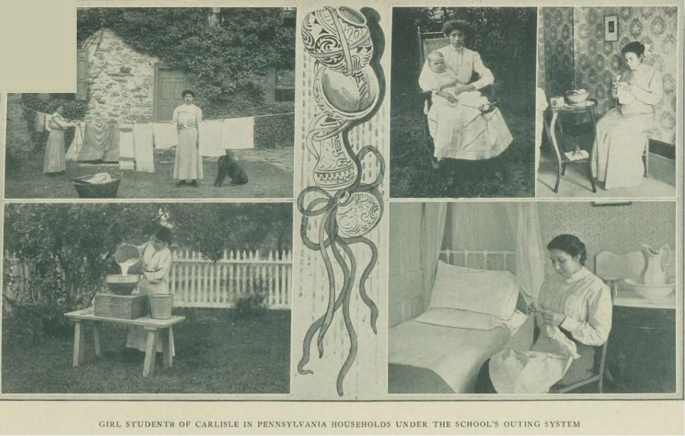
Caption: Girl students of Carlisle in Pennsylvania households under the school’s outing system Red Man ​(a magazine published at Carlisle), vol. 4, no. 1 (September 1911): 11.

Comprehension Questions for Documents 4 and 5
9) Describe ​ the differences in vocational training shown in the images above, which were featured in official publications of the Carlisle Indian school. Pay specific attention to the work being done by male and female students.

10)How is the gender division of labor shown in the images different from those of Native American cultures which you are familiar with or have studied?

11)Who is the intended audience of these images? How might this affect what is portrayed in the images?

Document 6
“Room details were changed on Tuesday. How proud each girl who is given the privilege of taking charge of a teacher’s room feels when entrusted with the care of the mantel ornaments, the pictures and the room bric-abrac, some of which are precious to the owners on account of the associations they have. A room-girl ought to feel that the room is her very own for a month, and she ought to try her best to keep it tidy, imagining all the while that the teacher is her visitor (except when giving necessary instructions.) This room detail is especially valuable in that it gives the girl an opportunity to handle with care delicate articles and to develop through individual instruction a taste for tidiness. A girl shows in a teacher’s room how she is going to keep her own home when she gets one. A woman who neglects her home and allows cob-webs to grow and dust to collect on the furniture or under it and in the hard places to reach, is a LA ZY woman, and if she has children and allows them to go even a little while with dirty hands and faces and wearing soiled clothing she is WORSE than a lazy woman, she is a disgrace to her sex, unless she be out of health, when there is some little excuse for such neglect.”

Source: ​The Indian Helper​, Dec. 4, 1891 (Vol. VII, No .13)

Document 6
12)What arguments does the above excerpt make as to the value of having girls at the Carlisle school take on the responsibility of cleaning the teacher’s rooms?

13)How would this further the white goal of assimilating Native women into American society?

Document 7
- “From her infancy in a cradleboard, Dilth-cleyhen, a Chiricahua Apache, learned the secrets of her people’s land. When it was time to harvest a special root, blossom, or fruit in a distance location, Dilth-cleyhen would accompany her mother and other women…. As she grew older, her mother told her, “You will learn… that most of the things we eat grow in a spcial place and in a special season. So we move about, following the bountiful food supply.” Women gathered mesquite bean pods in the flat lowlands, picked the rest fruit of the three-leabed sumac in the foothills…”
- “Navajo Irene Stewart witnessed the punishments ‘meted out to runaways. They were spanked and either locked up in a room or made to walk back and forth in front of the girls’ and boys’ dormitories. If a boy, he was dressed in girls’ clothing; if a girl, in boys’ clothing.’ Shaving girls’ heads as a punishment was also common.”

Source: Jacobs, M.D. ​White mother to a dark race : Settler colonialism, maternalism, and the removal of indigenous children in the American West and Australia, 1880-1940, ​p. 241, 255

Document 8
“The [Native American] girls, from six years of age up to marriage, are expected to help their mothers in the work. They are too valuable in the capacity of drudge to be spared to go [to school]. Another equally important obstacle is the fact that the girls constitute a part of the material wealth of the family, and bring, in open market after arriving at marriageable age, a certain price in horses or other valuable property. The parents fully realize that education will elevate their girls away from this property consideration”

Source: Richard Henry Pratt, Superintendent at Carlisle Indian School, quoted in​ Harper’s New Monthly Magazine​, 1881

Guiding Questions, Document 7 and 8
14)Summarize​ the value of girls & women in Chiricahua Apache society described in Document 7a.

15)Summarize​ the value of girls & women in Native American society described by Pratt in Document 8.

16)How could Pratt’s point of view in Document 8 be affected by his role as the founder and leader of the Carlisle Indian School? Does this make the document more or less reliable? Explain

17)How is punishment used to force traditional European gender roles on Native American children?

Document 9
“You have every chance where you are at to learn what Mr. Lipps [​the Carlisle superintendent​] wants the Oklahoma girls to learn especially, that is to keep house, learn to take care of property and to learn to keep yourself neat and clean. With Mrs. Robinson, you also have an opportunity of learning how to care for little children. Yet with all these advantages, you show no interest and go around doing your work in a ‘don’t care’ sort of way.. .. Our girls here just now are working hard and trying to make their grades in school and in their vocational work and they do not want any lazy, indifferent girls like you here.”

Letter dated Jan. 24, 1917, from Mrs. Nellie R. Denny, Chief Clerk in Charge of outings, to Louisa Beartail, a Carlisle student of the Creek nation.

Document 9
18)How does it show the expectations placed upon girls in the outing system?

19)How does the admonishment of Louis Beartail connect with what is shown in Document 6 and Document 7?

Document 10
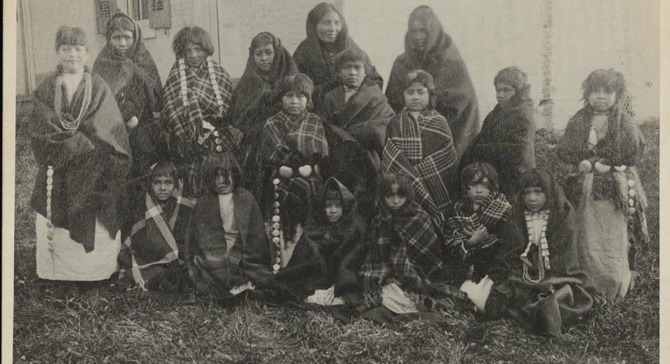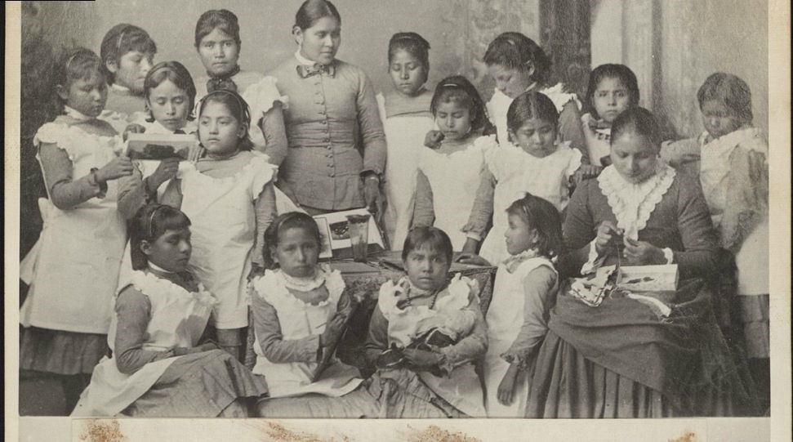
Top: A photograph of a group of Yankton and Pueblo girls arriving at Carlisle, 1884.
Bottom: The same group of students six months later.
Source: Carlisle Indian School Digital Resource Center, Dickinson College

Comprehension Questions for Document 10
20)Compare the presentation of the girls in the first picture to the presentation of the same girls in the second picture.

21)What do you think was the ​purpose​ of publishing these two images, which were published by the Carlisle Indian School?

