Carlisle Indian School Digital Resource Center
Analyzing Before and After Photographs & Exploring Student Files (primary documents) www.carlisleindian.dickinson.edu
Overview: Under the authority of the US federal government, Carlisle was the first federally funded off-reservation Indian boarding school. Founded in 1879 by Captain Richard Henry Pratt, it enrolled over 10,500 students by the time of its closing in 1918. Pratt believed that American Indians were the equals of European-Americans, and that Native American children immersed in mainstream Euro-American culture would become assimilated. To document his experiment, what scholar David Wallace Adams has referred to as “Education for Extinction,” Pratt commissioned John N. Choate to take before and after "contrast" photos to document the progress they were making in “civilizing” the Indian children. These photographs were then sent to officials in Washington, to potential charitable donors and to other reservations to recruit new students.
- Have students examine these two photographs, one at a time:
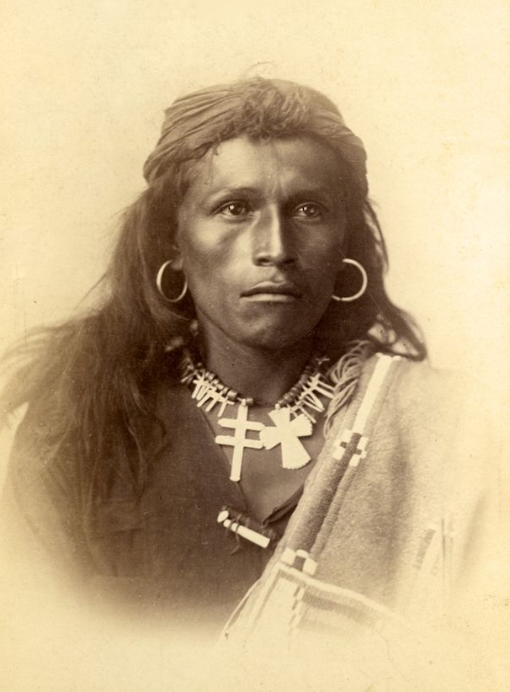
Tom Torlino, a Navajo student at the Carlisle Indian School, 1882

Describe what you see:
_______________________________________________________________________________________________________________________________________________________________________________________________________________________________________________________________________________________________________________________________________________________________________________________________________
Write a caption for this photograph:
__________________________________________________________________________________________________
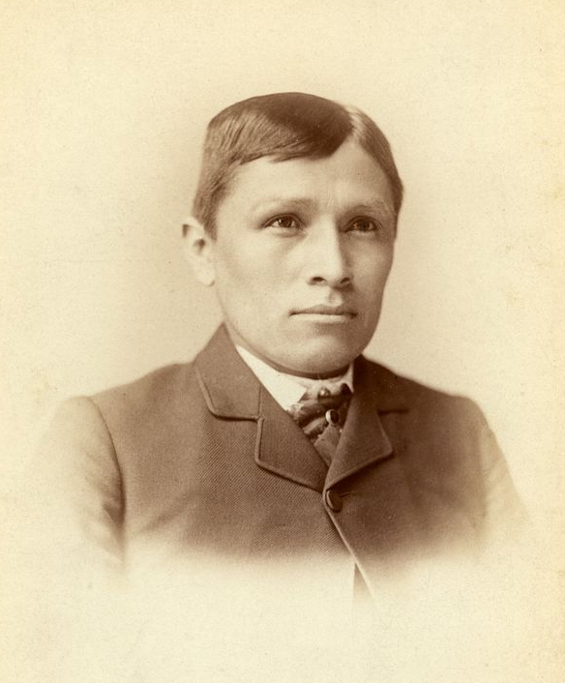
Tom Torlino, 1885

Describe what you see:
________________________________________________________________________________________________________________________________________________________________________________________________________________________________________________________________________________________________________________________________________________________________________________________________________
Write a caption for this photograph:
__________________________________________________________________________________________________

Compare and contrast these before and after photographs:
______________________________________________________________________________________________________________________________________________________________________________________________________________________________________________________________________________________________________
Choate took a number of before and after photos of students enrolled at the Carlisle Indian School – what do you think the purpose was? What do these photographs show/suggest?
______________________________________________________________________________________________________________________________________________________________________________________________________________________________________________________________________________________________________

- Go to the student file of Tom Torlino
What more can we learn about Tom Torlino from his file?
What Nation did he belong to?
When did he arrive at the Carlisle Indian School?
How long did he spend there?
When did he leave? And where did he go afterwards?
How much schooling did he have before coming to Carlisle?
What grade level did he complete at CIS?
One can find these two images of Tom Torlino in many publications and on many websites. Yet, there is a paucity of information about him as a student or person. What might this tell us?
- Read excerpt below of “Kill the Indian, and Save the Man”: Capt. Richard H. Pratt on the Education of Native Americans. Source: Official Report of the Nineteenth Annual Conference of Charities and Correction (1892), 46–59. Reprinted in Richard H. Pratt, “The Advantages of Mingling Indians with Whites,” Americanizing the American Indians: Writings by the “Friends of the Indian” 1880–1900 (Cambridge, Mass.: Harvard University Press, 1973), 260–271.
Excerpt

- What were Pratt’s goals? Provide your initial perceptions of the goals and aims of the Carlisle Indian Industrial School. Why did he want to found the Carlisle Indian School?

- Do the photos suggest that he succeeded? How else might one judge whether the school was a success or failure?

- What do you think Pratt meant by the term “truly civilized”? Describe traits and activities you
think Pratt would view as civilized:
_________________________________________________________________________________________________________________________________________________________________________________________________________________________________________________________________________________
- What do the student files reveal? Did the students conform, resist?
- Imagine you were a student at Carlisle, what might you have felt?
- What might you have done?
- Write a letter to Captain Pratt - what would you want to say?
Additional Before and After Photographs of Students Enrolled at the Carlisle Indian Industrial School (CIIS)
- Here's another early shot, also from 1882, of twelve Navajo Students -- including Tom Torlino, sitting in the front row, bottom left. And that's Richard Henry H Pratt looking on from the bandstand.
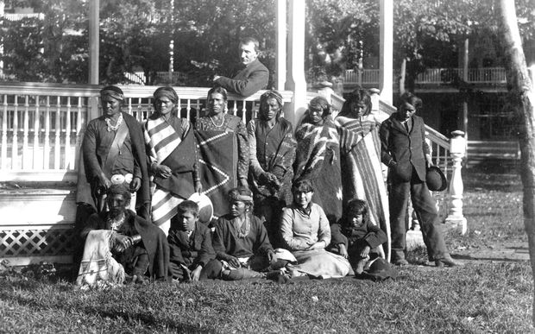
Navajo students who entered Carlisle October 21, 1882
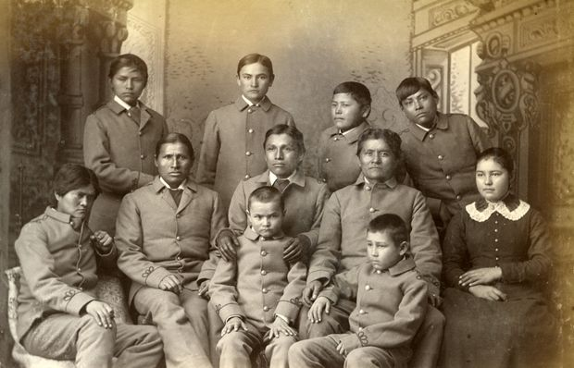
Navajo Group who entered Carlisle October 21, 1882 after some time at the school.
Have students examine these two photographs, one at a time and describe what they see.
Compare and contrast the images and what message they send.

Go to carlisleindian.dickinson.edu and search for the names of Navajo students who arrived on October 21, 1882.

Find the names of 4 students who arrived Oct. 21, 1882 and fill in the chart below.
Name of student | Where were they from: Nation/Place | How long did they stay at the school? | What did they do after the school?

After exploring their files, write a short summary of what we know about four of these individuals. Who are they, where did they come from? Were any of them relatives? How long did they stay at the school. What were their experiences like? Did they go on “outing?” Do we know anything about them after they left Carlisle? Was anything written about them?

- White Buffalo (Cheyenne) was a student at Carlisle from February 3, 1881 until he departed on June 17, 1884. He had prematurely gray hair.

This photo was taken in 1881, when he was 18. This photo of White Buffalo was taken about a year later.
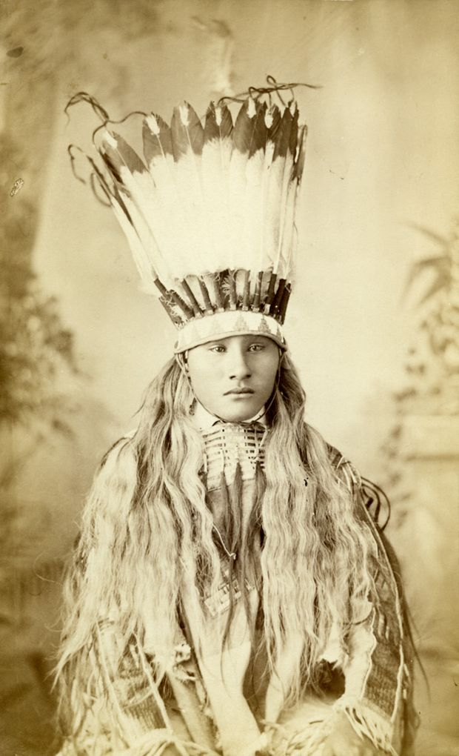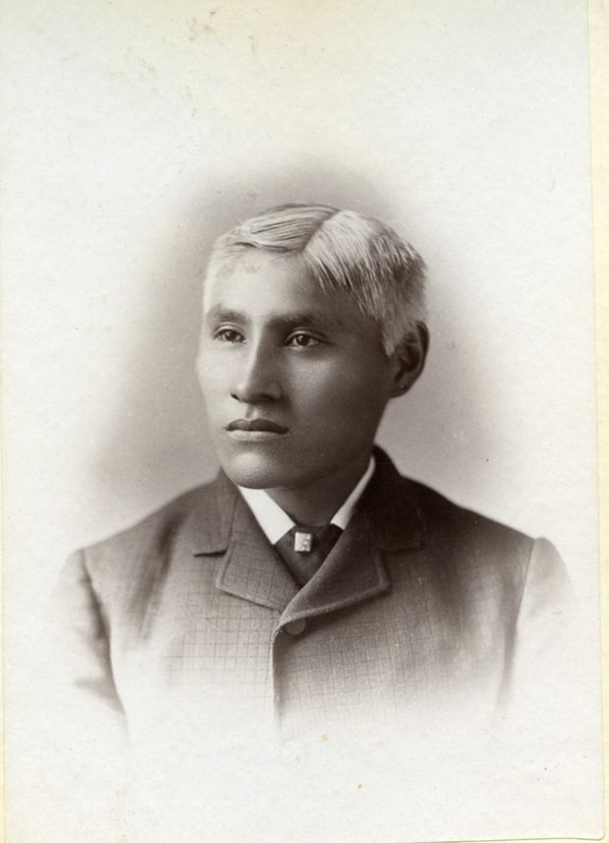
Photo A Photo B
Describe what you see in Photo A
Describe what you see in Photo B
Now go to another image of White Buffalo, Photo C
What else do you see in Photo C compared with Photo A?
Search All for “White Buffalo” at http://carlisleindian.dickinson.edu/student_files/explore
What other information can you find out about White Buffalo.
Where did he come from?
What Nation did he belong to?
What other name did he have? (White Headed Bull)

- Three Sioux students as they arrived at the The same three boys after three years at Carlisle Indian School in 1883 (Wounded Yellow Carlisle, wearing cadet uniforms
Robe, Timber Yellow Robe, and Henry
Standing Bear)
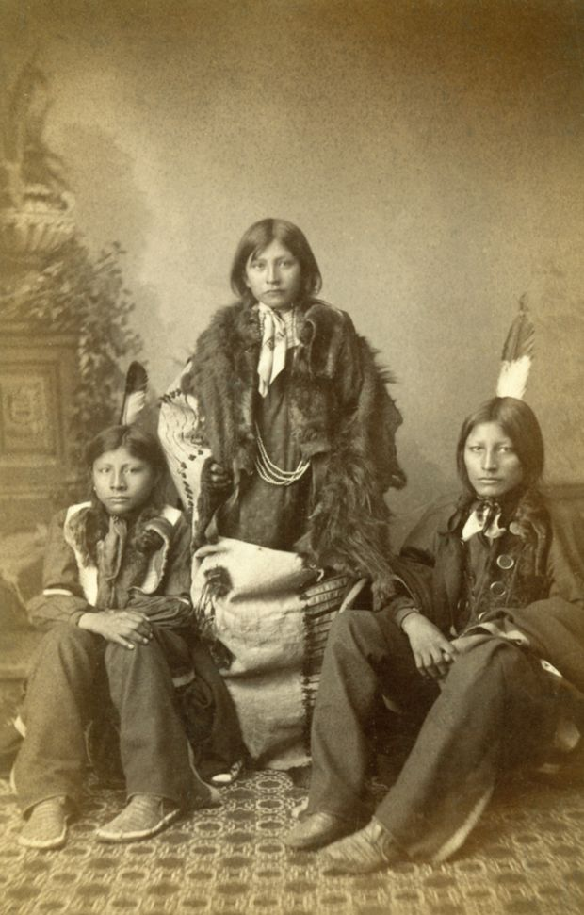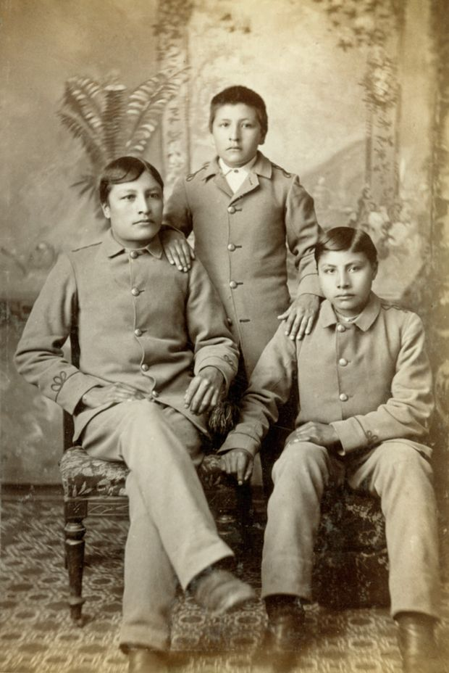
Have students examine these two photographs, one at a time and describe what they see.
Compare and contrast the images and what messages they send.

8) Four Pueblo children from Zuni, N.M., c. 1880 and then after sometime at the school.
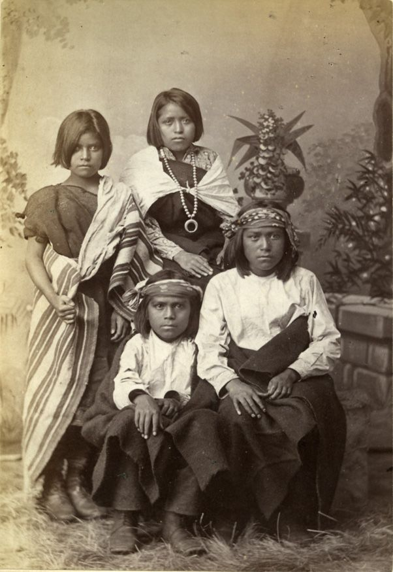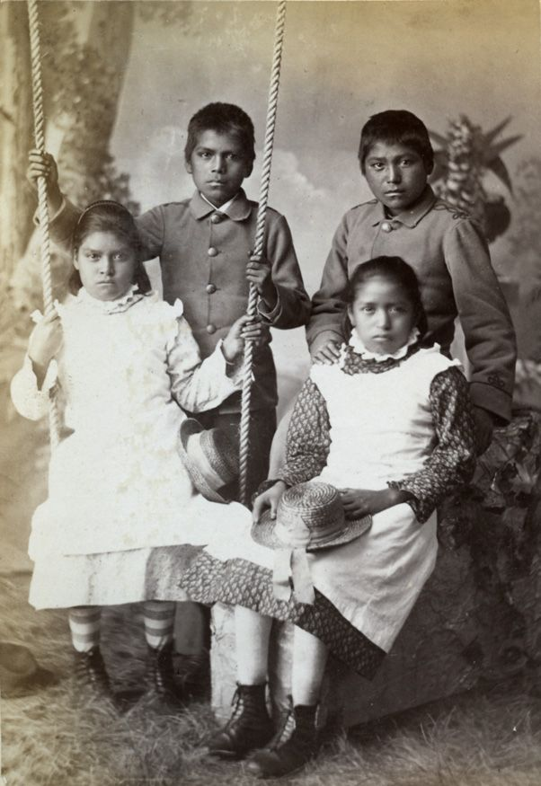
Have students examine these two photographs, one at a time and describe what they see.
Compare and contrast the images and what messages they send.
What can you tell about the setting of these photos?

- Chiracahua Apaches as they arrived at Carlisle from Fort Marion, Florida, November 4, 1886.
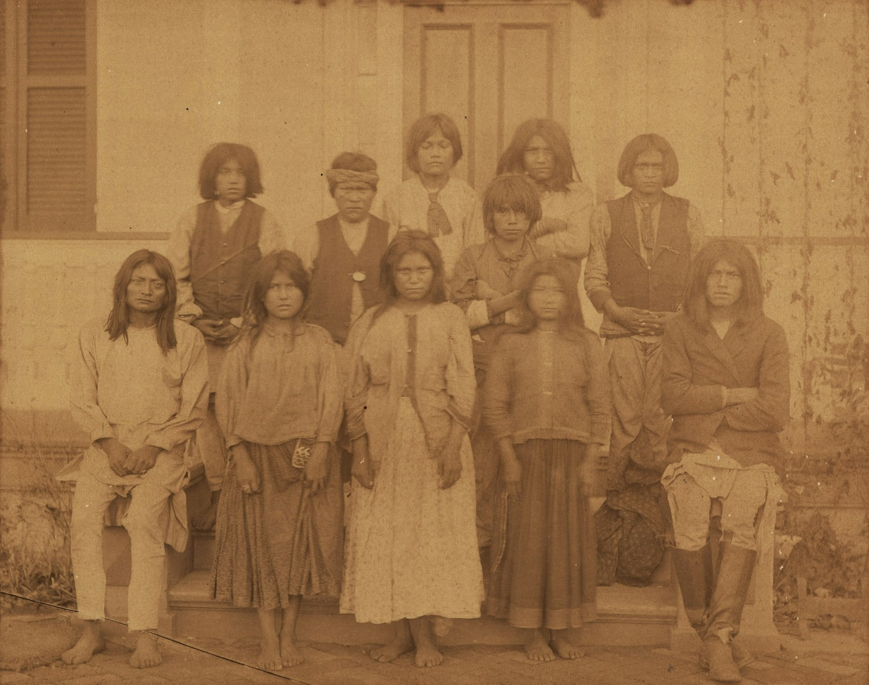
Photographer J. N. Choate. Hugh Chee, Bishop Eatennah, Ernest Hogee, Humphrey Escharzay,
Samson Noran, Basil Ekarden, Clement Seanilzay, Beatrice Kiahtel, Janette Pahgostatum,
Margaret Y. Nadasthilah, Fred’k Eskelsejah

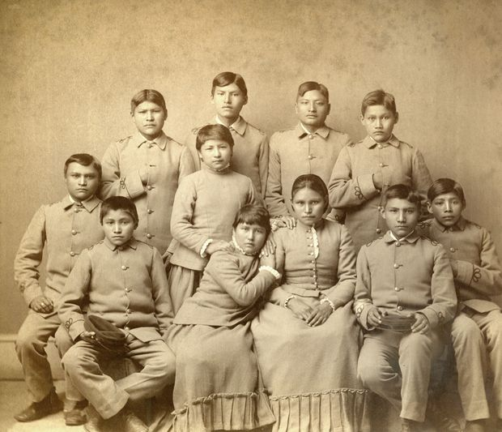
"Chiracahua Apaches four months after their arrival at Carlisle" March, 1887
Photographer J. N. Choate, Studio portrait (sitting and standing) of Samson Noran, Fred’k
Eskelsejah, Clement Seanilzay,Hugh Chee, Ernest Hogee, Margaret Y. Nadasthilah,
Humphrey Escharzay, Beatrice Kiahtel, Janette Pahgostatum, Bishop Eatennah, and Basil Ekarden.
Additional Resources: http://www.radiolab.org/story/photos-before-and-after-carlisle/

